**Find the common solution.**

1. System of Linear Equations
2. 2x+3y = 6

2x-3y = 6

Answer : 2x+3y =6 x=3

+ 2x -3y =6 2x+3y=6

------------------------------------ => 2*3 +3y =6

4x =12 3y = 6 - 2*3

X = 12/4 y =0

X=3

So: x=3, y= 0 .

1. X-4y =4

X+4y =4

Answer:

X-4y =4 x=4

+ x+4y = 4 x+4y=4

------------------------------ => 4+4y=4

2x =8 4y=4-4

X= 8/2 4y=0

X=4 y=0

So: x=4,y=0.

1. System of Linear Inequalities
2. 2x+3y > 6

2x-3y < 6

2x > 1

Answer:

1. Graph the inequality by finding the boundary line, then shading the appropriate area. 2x+3y > 6

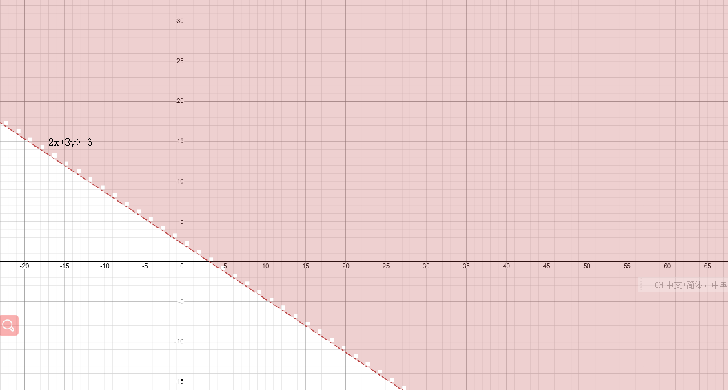

1. Graph the inequality by finding the boundary line, then shading the appropriate area. 2x+3y > 6

2x-3y < 6

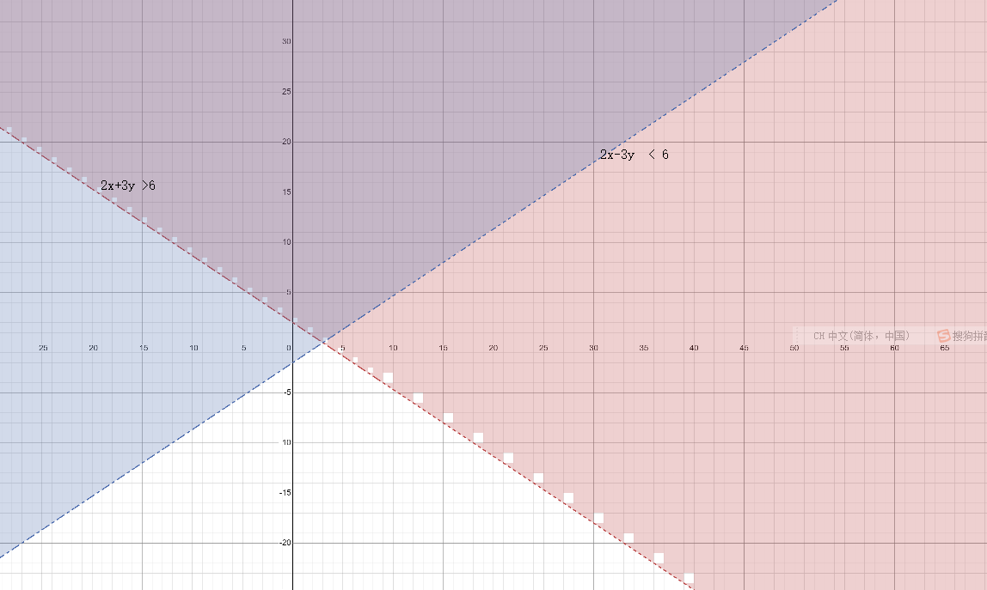

1. Find the boundary, draw the graph of the inequality, then shadow the appropriate area, and finally find the key points A (0.5,5/3), B (3,0) in the shadow overlap.

2x+3y > 6 , 2x-3y < 6 , 2x>1

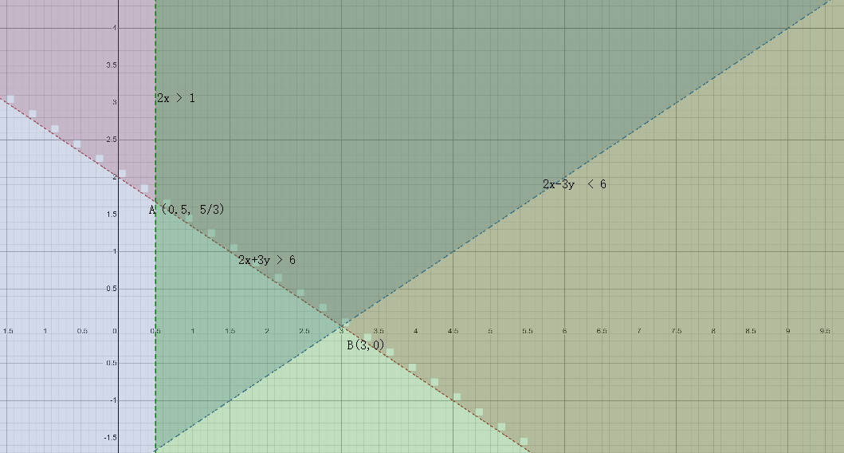

**So: X>0.5 and y>0**

1. X-4y <4

X+4y >4

Y < 2

Answer：

1. Graph the inequality by finding the boundary line, then shading the appropriate area. x-4y<4

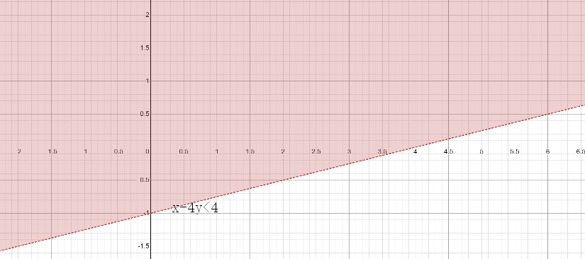

b. Graph the inequality by finding the boundary line, then shading the appropriate area. X-4y <4

X+4y >4

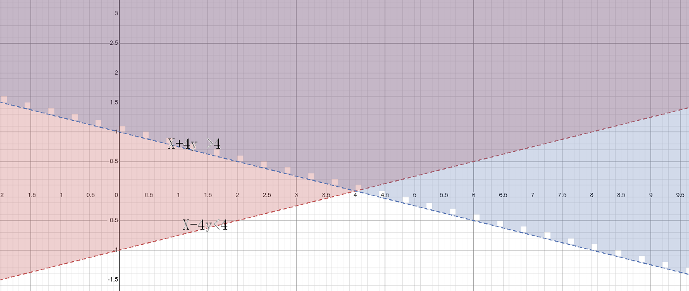

c. Find the boundary, draw the graph of the inequality, then shadow the appropriate area, and finally find the key points A (-4,2 ) B (4,0) C(12,2) in the shadow overlap.

X-4y <4 X+4y >4 Y < 2

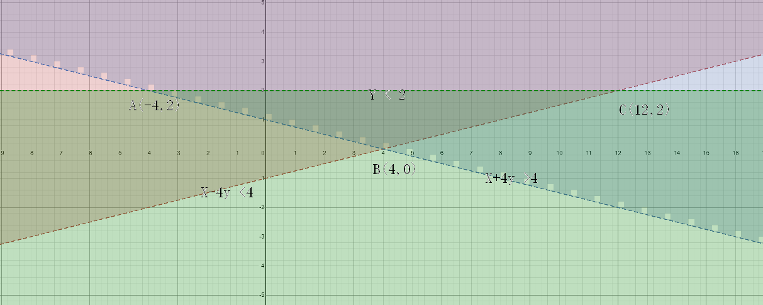

**So : -4 <x < 12 , 0< y < 2**

Ps ：Use graphic tools https://www.mathway.com/Algebra